SIMATS ENGINEERING
ASSESSMENT TOOL 2

COURSE NAME: Database Management Systems
COURSE CODE: CSA05

COURSE OUTCOME COVERED

CO1: Analyse DBMS architecture, different data models, schema types, and design ER/EER diagrams, relational schemas for case-based scenarios by identifying entities and relationships. (BL1, BL2)

Activity Tool : Concept Mapping (Medium)
Assessment Tool Weightage: 20%

QUESTIONS
Q.No | Question | Bloom's Level
1 | Construct a concept map linking the following terms: DBMS, Schema, Instance, Data Model, ER Diagram, Entity, Attribute, Relationship. | BL2 – Understand
2 | Create a concept map for the three-level ANSI/SPARC architecture showing data independence at each level. | BL2 – Understand
3 | Map the relationship between file-based systems and database systems, highlighting the problems solved by DBMS. | BL2 – Understand
4 | Design a concept map for ER diagram components: entity, weak entity, attribute types, relationship types, and participation constraints. | BL2 – Understand
5 | Construct a concept map comparing Hierarchical, Network, and Relational data models with their key properties. | BL2 – Understand
6 | Develop a concept map for the EER model showing how it extends the basic ER model with generalization, specialization, and aggregation. | BL2 – Understand
7 | Create a visual concept map for the DBMS software architecture, illustrating the flow from user request to data retrieval. | BL2 – Understand
8 | Map the data models discussed in CO1 to real-world applications and explain the suitability of each model. | BL2 – Understand
9 | Construct a concept map for schemas and instances, showing how they relate to physical and logical data independence. | BL2 – Understand
10 | Design a concept map for the roles and responsibilities in a DBMS environment: DBA, End User, Application Developer. | BL1 – Remember

Code of Conduct:

I THARUN KUMAR-192571017 certify that this submission is my original work and that I have adhered to the guidelines specified for this assessment.
I understand that any violation of academic integrity rules will result in disciplinary action.

Signature of the student:



RUBRICS FOR CALCULATION:

Criteria | Weightage | Level 4 (Exemplary) | Level 3 (Proficient) | Level 2 (Developing) | Level 1 (Beginning)
Concept  Identification | 25% | Identifies all key concepts from literature  accurately and comprehensively | Identifies most key  concepts with minor omissions | Identifies limited  concepts; some are  irrelevant or missing | Fails to identify essential concepts
Linkages | 25% | Establishes clear, meaningful, and accurate  relationships between concepts | Shows correct relationships  with minor gaps | Relationships are weak,  unclear, or partially incorrect | No meaningful relationships established
Organization | 20% | Concepts are well-structured  hierarchically with  logical flow and grouping | Mostly organized  with minor  structural issues | Some  organization  but lacks clear hierarchy | No logical organization or structure
Integration of Literature | 20% | Integrates multiple studies effectively to  show connections and comparisons | Shows some  integration of literature | Limited integration; mostly  isolated concepts | No integration of literature evidence

Concept Map 1: Core DBMS Terminology
Construct a concept map linking: DBMS, Schema, Instance, Data Model, ER Diagram, Entity, Attribute, Relationship.

Overview

Definition
- DBMS (Database Management System) is software that defines, creates, maintains and controls access to a database.
- Schema is the overall logical design/structure of the database, defined at the time of database design.
- Instance is the actual data stored in the database at a specific moment in time (a snapshot).
- Data Model is a set of concepts/notations used to describe the structure of a database (e.g., ER model, relational model).
- ER Diagram is a graphical representation of entities, attributes and relationships produced using the ER data model.
- Entity is a real-world object/concept that has independent existence and is distinguishable from other objects (e.g., Student).
- Attribute is a property or characteristic that describes an entity (e.g., Name, RollNo).
- Relationship is an association among two or more entities (e.g., Student ENROLLS_IN Course).

Purpose
- Shows how the foundational vocabulary of DBMS is interconnected rather than isolated definitions.
- Helps learners see that a Data Model is the language used to build an ER Diagram, which in turn is translated into a Schema.

Key Features
- DBMS is the umbrella system that manages Schema, Instance and enforces the Data Model.
- Schema is stable/rarely changed; Instance changes every time data is inserted, updated or deleted.
- ER Diagram is a visual tool built from Entities, Attributes and Relationships, following a chosen Data Model.
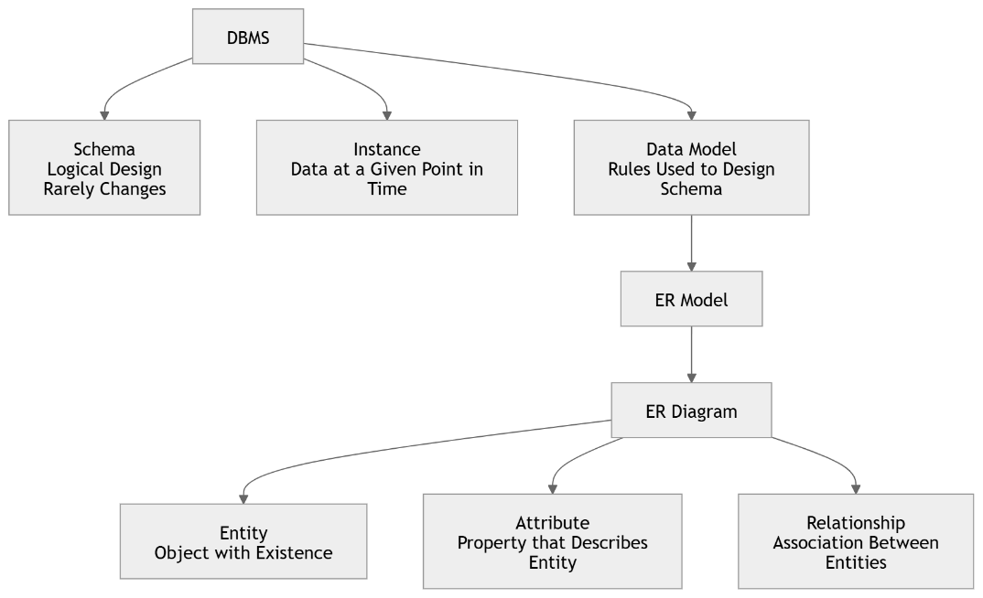
Concept Hierarchy

Components

Component | Description
DBMS | Software layer that manages data, schema, instances and user access.
Schema | Blueprint/structure of the database (tables, fields, constraints).
Instance | Actual content of the database at one moment; changes over time.
Data Model | Conceptual toolset (e.g., ER, Relational) to describe schema.
ER Diagram | Diagrammatic output of applying the ER data model.
Entity | A distinguishable real-world object represented in the schema.
Attribute | A named property that characterizes an entity.
Relationship | A meaningful association connecting two or more entities.

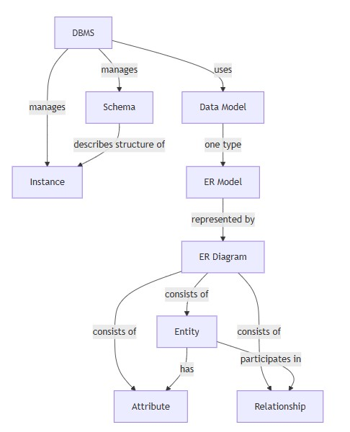
Relationship

Examples

- DBMS example: MySQL, Oracle, PostgreSQL.
- Schema example: CREATE TABLE Student(RollNo, Name, Dept) definition.
- Instance example: the 500 current student rows stored today.
- ER Diagram example: Student — ENROLLS_IN — Course diagram.

Summary

- DBMS is the managing software; Schema is the design; Instance is the live data.
- Data Model is the conceptual language; ER Diagram is its graphical output.
- Entities, Attributes and Relationships are the building blocks that make up an ER Diagram and, ultimately, the Schema.

Concept Map 2: Three-Level ANSI/SPARC Architecture
Create a concept map for the three-level ANSI/SPARC architecture showing data independence at each level.

Overview

Definition
● The ANSI/SPARC architecture divides a database system into three levels: External, Conceptual and Internal, to separate user views from physical storage.

Purpose
- Achieves data abstraction so users are shielded from storage details.
- Provides data independence so changes at one level do not force changes at another.

Key Features
- External Level: multiple user/application-specific views of the database.
- Conceptual Level: single, community/global logical structure of the whole database.
- Internal Level: physical storage structures, indexes, file organization.
- Mappings exist between External↔Conceptual and Conceptual↔Internal levels.

Concept Hierarchy

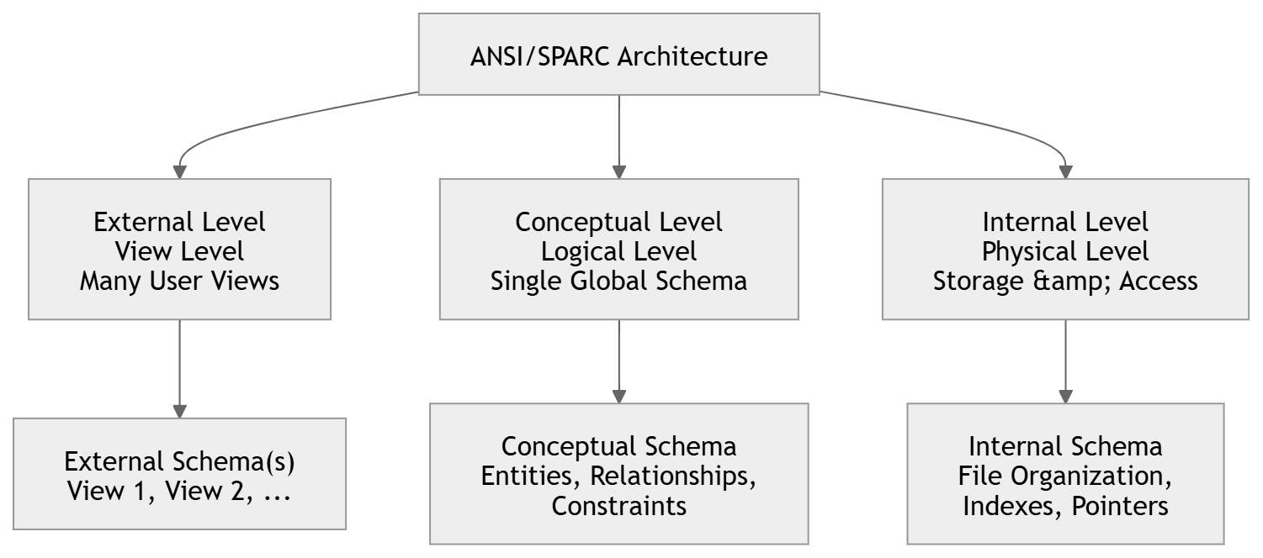

Components

Component | Description
External Level | Defines how individual users see the data (custom views).
Conceptual Level | Community view; describes entities, relationships, constraints for the whole enterprise.
Component | Description
Internal Level | Describes physical storage: indexing, file structures, access paths.
Logical Data Independence | Ability to change conceptual schema without changing external schemas.
Physical Data Independence | Ability to change internal schema without changing conceptual schema.

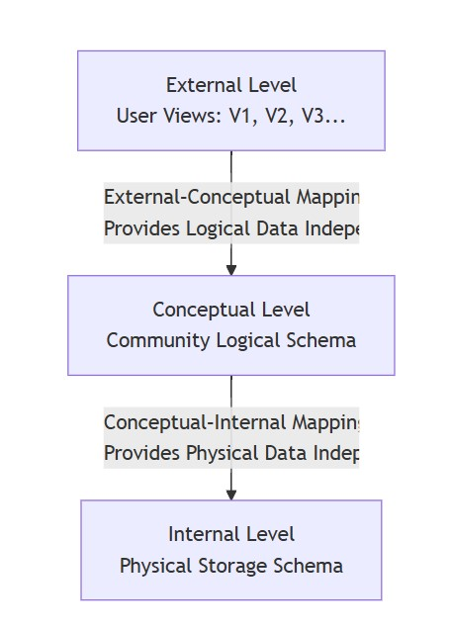
Multi
-
Level Architecture

Quick

Reference

Term | Meaning
View Level | Another name for the External Level.
Logical Level | Another name for the Conceptual Level.
Physical Level | Another name for the Internal Level.
Mapping | Rules that translate a request from one level to the level below it.

Examples

- External: a payroll clerk's view showing only salary-related columns.
- Conceptual: full Employee table with all attributes and relationships.
- Internal: B-tree index on EmployeeID stored on disk.

Summary

- Three levels separate concerns: what the user sees, what the whole system logically contains, and how it is physically stored.
- Logical data independence protects external views from conceptual schema changes.
- Physical data independence protects the conceptual schema from internal storage changes.

Concept Map 3: File-Based Systems vs Database Systems
Map the relationship between file-based systems and database systems, highlighting the problems solved by DBMS.

Overview

Definition
- A file-based system stores data in separate flat files managed directly by application programs.
- A database system centralises data storage and access through a DBMS layer shared by all applications.

Purpose
● Illustrates why database systems replaced file-based systems by resolving the latter's structural weaknesses.

Key Features
- File systems: data and program are tightly coupled; each application maintains its own files.
- Database systems: data is centralised, self-described (via schema/catalog) and shared across applications.

Concept Hierarchy

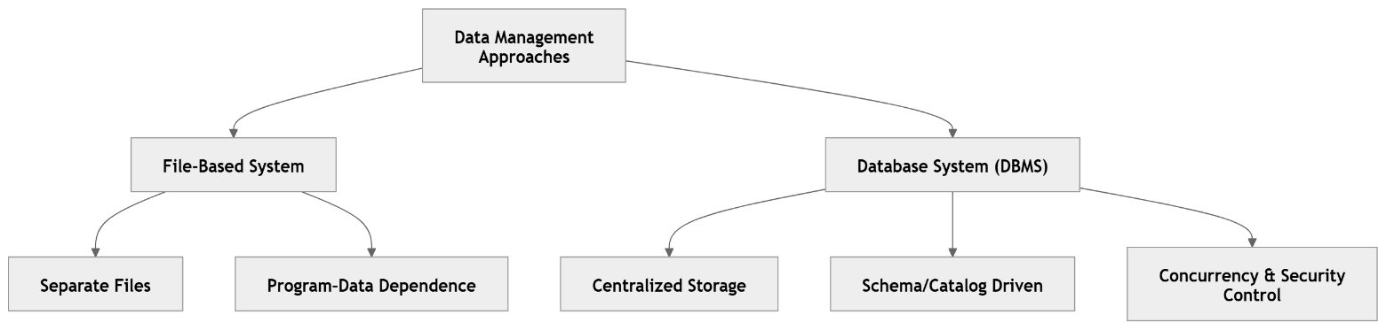

Comparison

Feature | File-Based System | Database System (DBMS)
Data Redundancy | High – same data duplicated across files | Minimised via normalisation & central storage
Data Sharing | Difficult; program-specific files | Easy; shared through DBMS
Data Independence | None; programs depend on file structure | Provided (logical & physical)
Integrity Constraints | Enforced in application code | Enforced centrally in schema
Concurrent Access | Not well supported | Managed via concurrency control
Security | Weak, per-file | Centralised authorisation

Problem → Solution Mapping

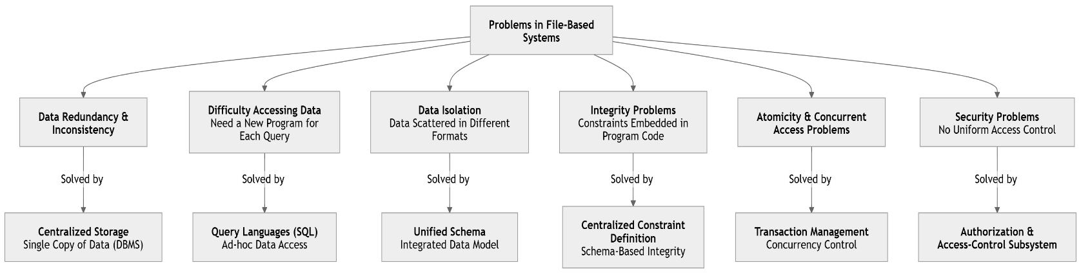

Examples

- File-based: COBOL payroll program reading its own EMP.DAT file.
- Database: an ERP system where Sales, HR and Finance modules all query one shared database via a DBMS.

Summary

- File-based systems suffer from redundancy, inconsistency, isolation, poor security and weak concurrency handling.
- DBMS solves these by centralising data, enforcing schema-driven integrity, and providing transaction, security and query support.

Concept Map 4: ER Diagram Components
Design a concept map for ER diagram components: entity, weak entity, attribute types, relationship types, and participation constraints.

Overview

Definition
● An ER Diagram graphically models data requirements using entities, attributes, relationships and constraints.

Purpose
● Breaks down every notational building block of the ER model so relationships between the components are visible at a glance.

Key Features
- Entities can be strong (independent) or weak (dependent on an owner entity).
- Attributes may be simple, composite, single-valued, multi-valued or derived.
- Relationships carry a degree (unary, binary, ternary) and cardinality (1:1, 1:N, M:N).
- Participation constraints specify whether an entity's involvement in a relationship is total or partial. Concept Hierarchy

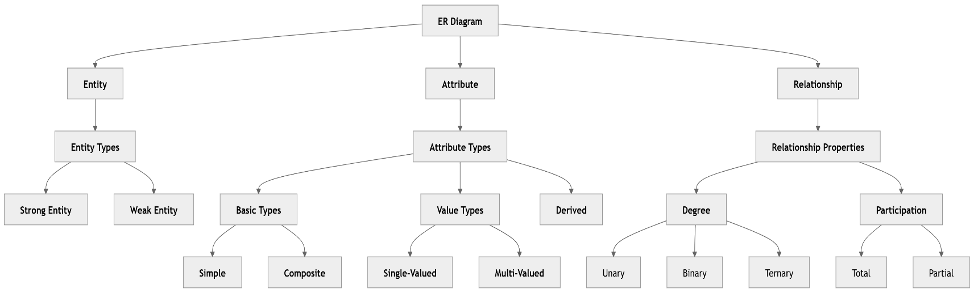

Types / Classification

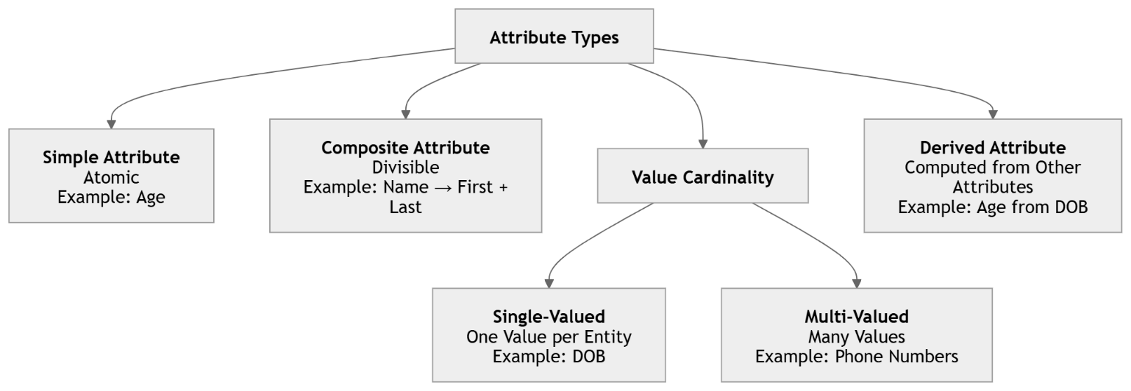

Components

Component | Description
Strong Entity | Has its own primary key; exists independently.
Weak Entity | Has no primary key of its own; depends on an owner (identifying) entity, uses a partial key.
Simple Attribute | Cannot be divided further, e.g. Age.
Composite Attribute | Can be divided into sub-parts, e.g. Name = First + Last.
Multi-valued Attribute | Can hold multiple values, e.g. Phone Numbers.
Derived Attribute | Computed from another attribute, e.g. Age from DateOfBirth.
Relationship Degree | Number of entities participating: unary, binary, ternary.
Participation Constraint | Total (double line, mandatory) or Partial (single line, optional).

Relationship

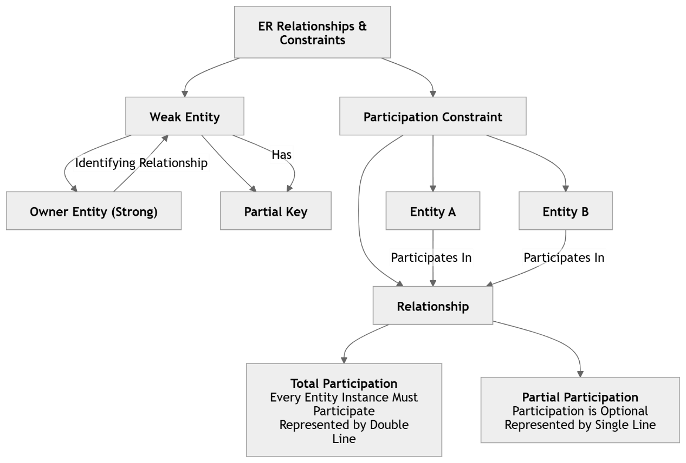

Quick Reference

Term | Meaning
Double rectangle | Weak entity
Double diamond | Identifying relationship
Dashed underline | Derived attribute
Double line | Total participation
Oval with lines | Multi-valued attribute

Examples

- Strong entity: Employee (PK: EmployeeID).
- Weak entity: Dependent (owned by Employee, partial key: DependentName).
- Total participation: every Loan must be associated with a Bank (mandatory).

Summary

- Entities may be strong or weak; weak entities rely on an identifying relationship with an owner.
- Attributes vary in nature: simple, composite, multi-valued, derived.
- Relationships are described by degree and constrained by cardinality and participation (total/partial).

Concept Map 5: Hierarchical, Network and Relational Data Models
Construct a concept map comparing Hierarchical, Network, and Relational data models with their key properties.

Overview

Definition
- A data model is a collection of concepts used to describe the structure, operations and constraints of a database.
- Hierarchical, Network and Relational are three classical (legacy-to-modern) data models.

Purpose
● Contrasts the structural philosophy (tree, graph, table) of each model to show their evolution and tradeoffs.

Key Features
- Hierarchical Model: tree structure with parent-child (1:N) links only.
- Network Model: graph structure allowing many-to-many relationships via owner-member sets.
- Relational Model: data organised into tables (relations) linked by keys; based on set theory.

Concept Hierarchy

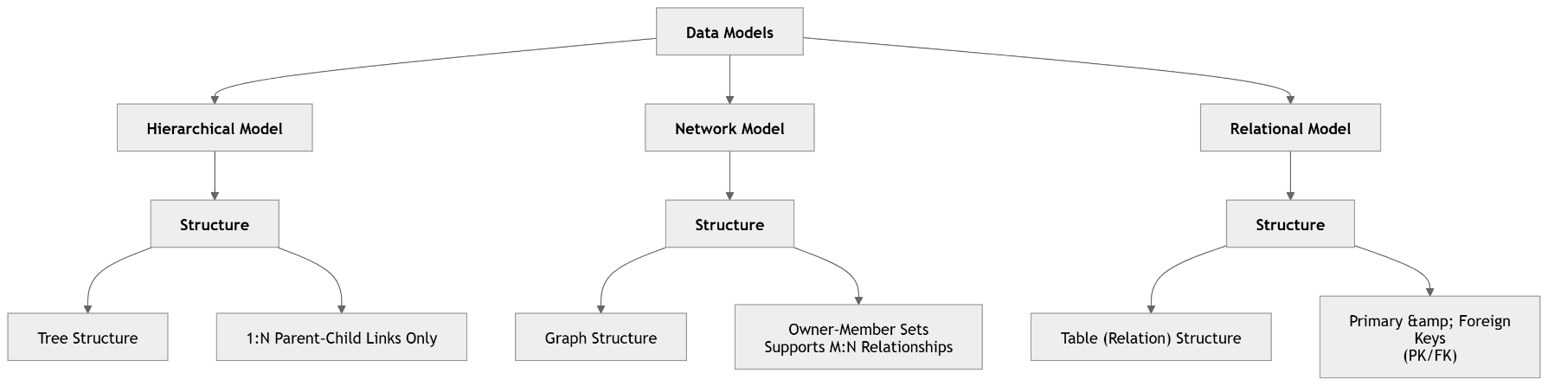

Components

Component | Description
Hierarchical Model | Records organised as a tree; each child has exactly one parent.
Network Model | Records organised as a graph; a member can have multiple owners via sets.
Relational Model | Data stored as rows/columns in tables; relationships via primary/foreign keys.

Comparison

Property | Hierarchical | Network | Relational
Structure | Tree (one root) | Graph (multiple parents) | Set of tables
Relationship type | 1:N only | 1:1, 1:N, M:N | 1:1, 1:N, M:N (via keys)
Navigation | Top-down traversal | Pointer/set traversal | Declarative (SQL)
Flexibility | Rigid | Complex but flexible | Highly flexible
Redundancy | Can be high | Moderate | Reduced via normalisation
Example System | IMS (IBM) | IDMS | MySQL, Oracle, PostgreSQL

Examples

- Hierarchical: an organisation chart stored as IMS records (Company → Department → Employee).
- Network: a university system where a Student can belong to multiple Clubs and vice versa.
- Relational: Student table linked to Course table via an Enrollment table using foreign keys.

Summary

- Hierarchical model is simplest but restricted to strict 1:N tree relationships.
- Network model relaxes this to support M:N via owner-member sets, at the cost of navigational complexity.
- Relational model replaces navigation with declarative, key-based access, offering the most flexibility and is the current industry standard.

